

**Tribhuvan University**

**Faculty of Humanity and Social Sciences**

**Bachelor’s in computer application**

**Daily Activities & Personal Finance Tracker**

**Submitted To**

**Department of Computer Application**

**Padmashree International College**

**Subidhanagar, Tinkune**

**Submitted By**

**Jenish Limbu** **Kiran Jethara**

Semester-4th Semester-4th

Registration No: Registration No:

6-2-622-28-2021 6-2-622-29-2021



**Tribhuvan University** **Faculty of Humanities and Social Science** **Padmashree International College**

**SUPERVISOR’S RECOMMENDATION**

I hereby recommend that this project prepared under my supervision by **Jenish Limbu** and **Kiran Jethara** entitled “**Daily Activities & Personal Finance Tracker”** in partial fulfillment of the requirements for the degree of Bachelor of Computer Application recommended for the final evaluation.

……………….

Mr. Basanta Chapagain

Project Supervisor

Department of Computer Application

Padmashree International College



**Tribhuvan University**  **Faculty of Humanities and Social Sciences**  **Padmashree International College**

**LETTER OF APPROVAL**

This is to certify that this project prepared by **Jenish Limbu** and **Kiran Jethara** entitled “**Daily Activities & Personal Finance Tracker”** in partial fulfillment of the requirements for the degree of bachelor’s in computer application has been evaluated. In our opinion it is satisfactory in the scope and quality as a project for the required degree.

|  |  |
| --- | --- |
| **………………………………..**  Mr. Basanta Chapagin  Project Supervisor  Department of Computer Application  PadmaShree International College | **………………………………….**  Mr. Ramesh Kumar Pudasaini  Program Coordinator  Department of Computer Application  PadmaShree International College |
| **………………………..**  **Internal Examiner** | **…………………………**  **External Examiner** |

**Table of Content**

**Chapter 1: Introduction** 1

**1.1** **Introduction** 1

**1.2 Problem Statement** 1

**1.3 Objectives** 2

**1.4 Scopes and Limitation** 2

**1.5 Report Organization** 3

**1.5.1 Introduction** 3

**1.5.2 Background Study and Literature Review** 3

**1.5.4 Implementation and Testing** 3

**1.5.5 Conclusion and Future Recommendation** 3

**Chapter 2: Background Study and Literature Review** 4

**2.1 Background Study** 4

**2.2 Literature Review** 4

**Chapter 3: System Analysis and Design** 5

**3.1 System Analysis** 5

**3.1.1 Requirement Analysis** 6

**3.1.2 Feasibility Analysis** 8

**3.1.3. Data Modelling (ER-Diagram)** 10

**3.1.4 Process Modelling(DFD)** 11

**3.2. System Design** 13

**3.2.1. Architectural Design** 13

**3.2.3. Interface Design(UI Interface / Interface Structure Diagrams)** 13

**3.2.5. System Flowchart** 19

# 

# **Chapter 1: Introduction**

## **Introduction**

The “Daily Activities & Personal Finance Tracker” is a system which helps to view and analyze the daily tasks, income and expenses of an individual .It is a system developed to track the tasks, income and expenses. It serves as a valuable tool in this regard, helping individuals to plan, monitor, and optimize their daily tasks while also keeping a close eye on their financial health. In short, this system is designed to record and analyze time and money of a user.

## **1.2 Problem Statement**

On a daily basis, many people fail to complete all their tasks or forget to prioritize them based on their importance. This often happens because they do not track their tasks according to their due dates or importance. Consequently, they miss deadlines and fail to complete tasks in a timely manner.

In financial matters, many people overspend without considering their income or without being aware of how much money they are spending on a daily basis. They do not manage their spending through proper budgeting, which leads to unnecessary expenses and increased overall costs. By failing to track their expenditures and plan their finances, they often find themselves facing unexpected financial difficulties.

## **1.3 Objectives**

The objectives of “Daily Activities & Personal Finance Tracker” are:

* To provide users with a comprehensive view and tracking system for their daily activities and personal finance-related data.
* To enable users to analyze and make decisions about their tasks and income/expenses.
* To assist users in maintaining disciplined habits.

## **1.4 Scopes and Limitation**

**1.4.1 Scope of the project**

The "Daily Activities and Personal Finance Tracker" is a comprehensive web application designed to help users manage their daily tasks and track their income and expenses efficiently. Users can organize their tasks by priority and due dates, enabling better time management and productivity. Additionally, the application provides tools for budgeting and expense tracking, helping users gain insights into their spending habits and financial status .

**1.4.2 Limitations**

The limitations of "Daily Activities and Personal Finance Tracker" are:

* Internet access is required as it is a web-based application.

## **1.5 Report Organization**

### **1.5.1 Introduction**

This chapter introduces the system, outlining its objectives and limitations, and explains the reasons behind its development.

### **1.5.2 Background Study and Literature Review**

This chapter presents an overview of the current issues, highlights the significance of developing the system, and defines key concepts related to it, while also providing a critical review and summary of existing research in the field.

**1.5.3 System Analysis and Design**

Different requirements such as functional and non-functional requirements, feasibility analysis, ER diagrams, DFDs, system architecture, database schema, and interface design are included in this chapter.

### **1.5.4 Implementation and Testing**

This chapter focuses on the tools utilized in system development, detailing the implementation process and presenting the results of the tests conducted.

### **1.5.5 Conclusion and Future Recommendation**

This chapter provides a brief summary of the lessons learned, the outcomes, and the conclusions of the entire project. It explains what has been accomplished and suggests potential areas for further improvement.

# **Chapter 2: Background Study and Literature Review**

## **2.1 Background Study**

Numerous System Catering to "daily activities and personal finance tracker” populate the market, with personal experiences and analyses applied to platform like Todoist, Clocklify, Ynab etc. Currently, users contend with a divide, necessitating separate applications for managing daily activities and monitoring personal finances.

## **2.2 Literature Review**

Daily activities and personal finance tracker systems have evolved from simple digital tools to sophisticated mobile and web-based applications, offering a range of benefits for users. These systems enhance productivity by identifying and optimizing time management, facilitate better financial management through budgeting and goal setting, and empower data-driven decision-making with detailed analytics. Despite their advantages, challenges such as privacy concerns, user engagement, complexity, and integration with other platforms need to be addressed. Future trends in AI, voice and gesture controls, blockchain technology, and wearable device integration promise to further enhance the functionality and accessibility of these systems, making them indispensable tools for personal management in the digital age.

# **Chapter 3: System Analysis and Design**

## **3.1 System Analysis**

Agile's emphasis on flexibility, user collaboration, and iterative development makes it an ideal choice for developing our system. This approach ensures that the system remains adaptable and responsive to user feedback, ultimately delivering a high-quality product. Since our system requirements weren’t clear and may include additional features in the future, Agile methodology is the best-suited approach for our project.

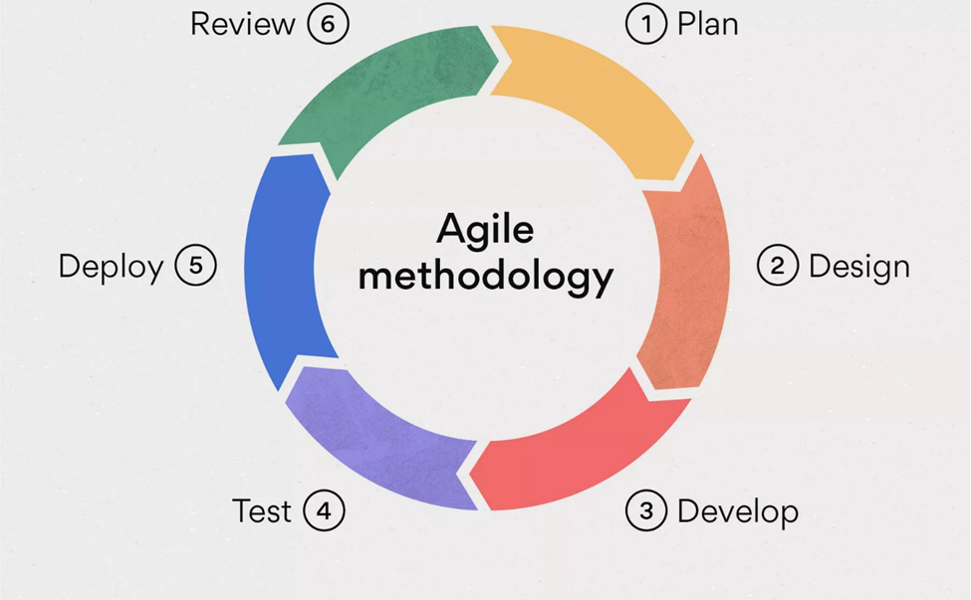

**Figure 1: Agile Methodology**

### **3.1.1 Requirement Analysis**

#### **i. Functional Requirement**

The functional requirements are listed below:

1. **Users**

* The system should authenticate and authorize the users while logging in.
* The system should track the tasks added by the users.
* Users should add the income and expenses category.
* Users should allocate the budget for his/her monthly expenses.
* The system should track the income and expenses of users.

1. **Admin**

* The system should authenticate, authorize and redirect to the admin dashboard.
* Admin may deactivate users.
* Admin should be able to change the website UI/(motives) contents.
* Admin should get messages sent by the website visitors.

**Use Case Diagram of Daily Activities and Personal Finance Tracker**

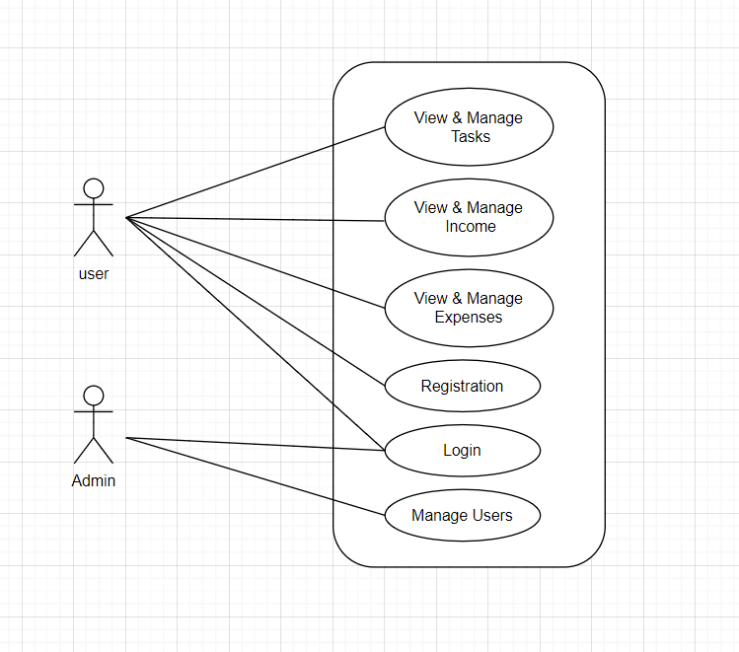

**Fig 2: Use Case Diagram of Daily Activities and Personal Finance Tracker**

#### **ii. Non-Functional_Requirement**

1. **Availability**

The system should be available at any time, providing users with 24/7 access every day of the year. Users should access the system at any time, requiring devices and an internet connection. Additionally, the system should be compatible with multiple browsers ensuring seamless and flexible access across various platforms. This high level of system availability should guarantees that users can rely on the service whenever they need it.

1. **Accuracy**

The system should be 100% accurate with the inputted data and the tracking results.

1. **Reliability**

The system must be reliable, as it plays a vital role in tracking and providing data about users' tasks, incomes, and expenses.

1. **Security**

The system must protect all the users data and authorize, authenticate the users while logging in.

### **3.1.2 Feasibility Analysis**

#### **i. Technical Feasibility**

The Daily Activities and Personal Finance Tracker system is technically feasible due to its reliance on modern, robust technologies. The front-end will use HTML5, CSS3, and JavaScript, while the back-end will be powered by php with database MySQL.

#### **ii. Operational Feasibility**

The Daily Activities and Personal Finance Tracker ensures smooth operation by offering a good UI, seamlessly fitting into daily routines and valuing user feedback for continuous improvement. The system optimizes user time and delivers trustworthy data. It can be operated by normal user with no professional experience.

#### **iii. Economic Feasibility**

The Daily Activities and Personal Finance Tracker is economically feasible enough to run the system. The system is going to be created with free sources and the users won’t have to pay to use this system.

#### **iv. Schedule Feasibility**

The system is being developed with the below timing schedules.

**Fig 3: Gantt Chart**

### **3.1.3. Data Modelling (ER-Diagram)**

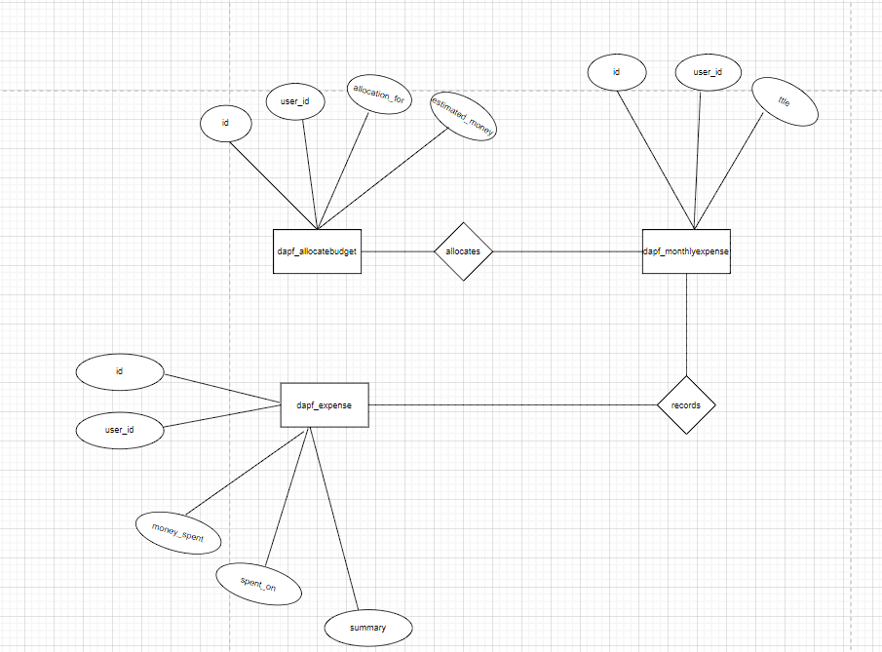

**Figure: ER Diagram of Expense**

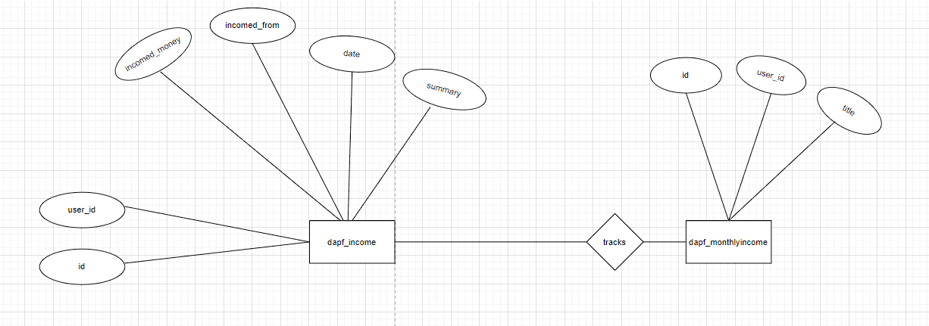

**Figure: ER Diagram of Income**

### **3.1.4 Process Modelling(DFD)**

**Level 0 DFD**

The Level 0 Data Flow Diagram (DFD) for the Daily Activities and Personal Finance Tracker illustrates the primary interactions between Users and the System. Users have the ability to monitor daily activities, handle their finances, and establish budgets. Core processes include logging daily activities, recording expenses, managing income, setting and adjusting budgets, and logging in/out. Data flows cover activity logging, expense recording, income management, budget allocation, and authentication credentials. This streamlined diagram showcases the key functionalities and communication pathways within the system, facilitating effective management of daily routines and financial matters.

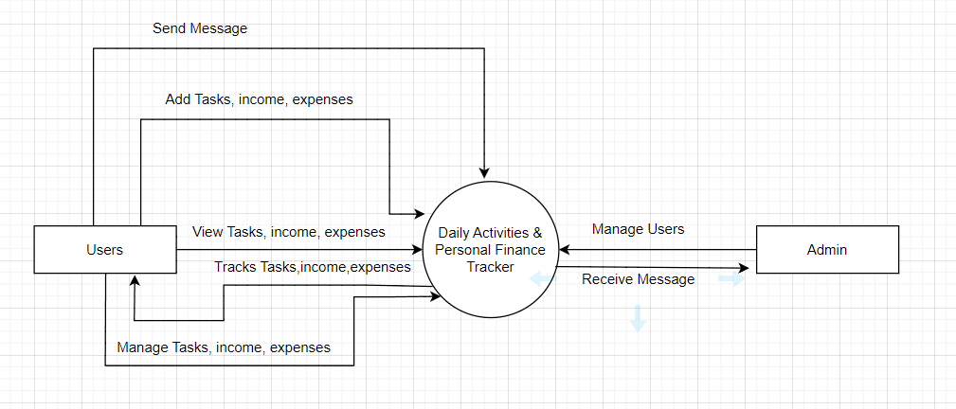

**Figure: Level 0 DFD**

**Level 1 DFD**

The Level 1 DFD provides a more detailed view of the Daily Activities and Personal Finance Tracker. It breaks down the processes into sub-processes and includes database/data storage components.

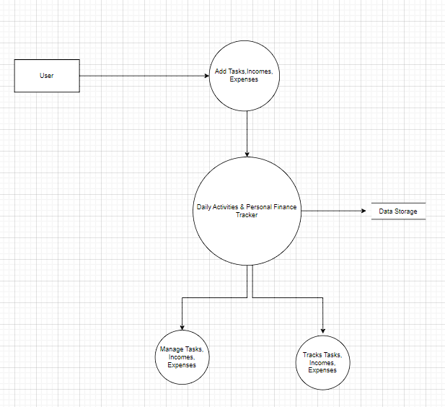

**Figure: Level 1 DFD**

## **3.2. System Design**

### **3.2.1. Architectural Design**

Three tier architecture is being implemented in this system. The Figure is given below:

**Fig 3: Web Architectural Design.**

### **3.2.3. Interface Design(UI Interface / Interface Structure Diagrams)**



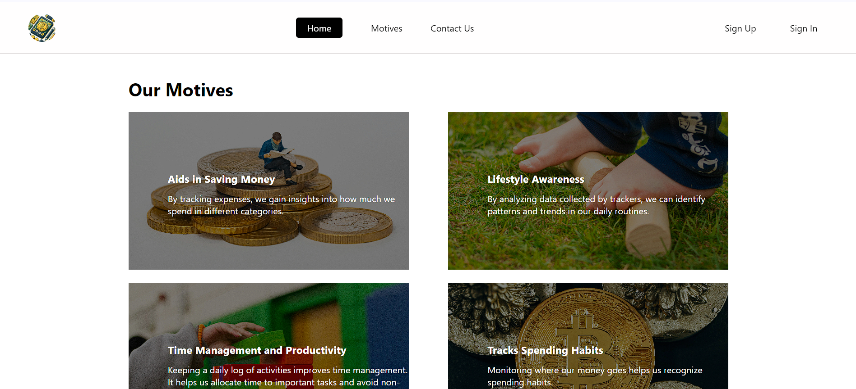

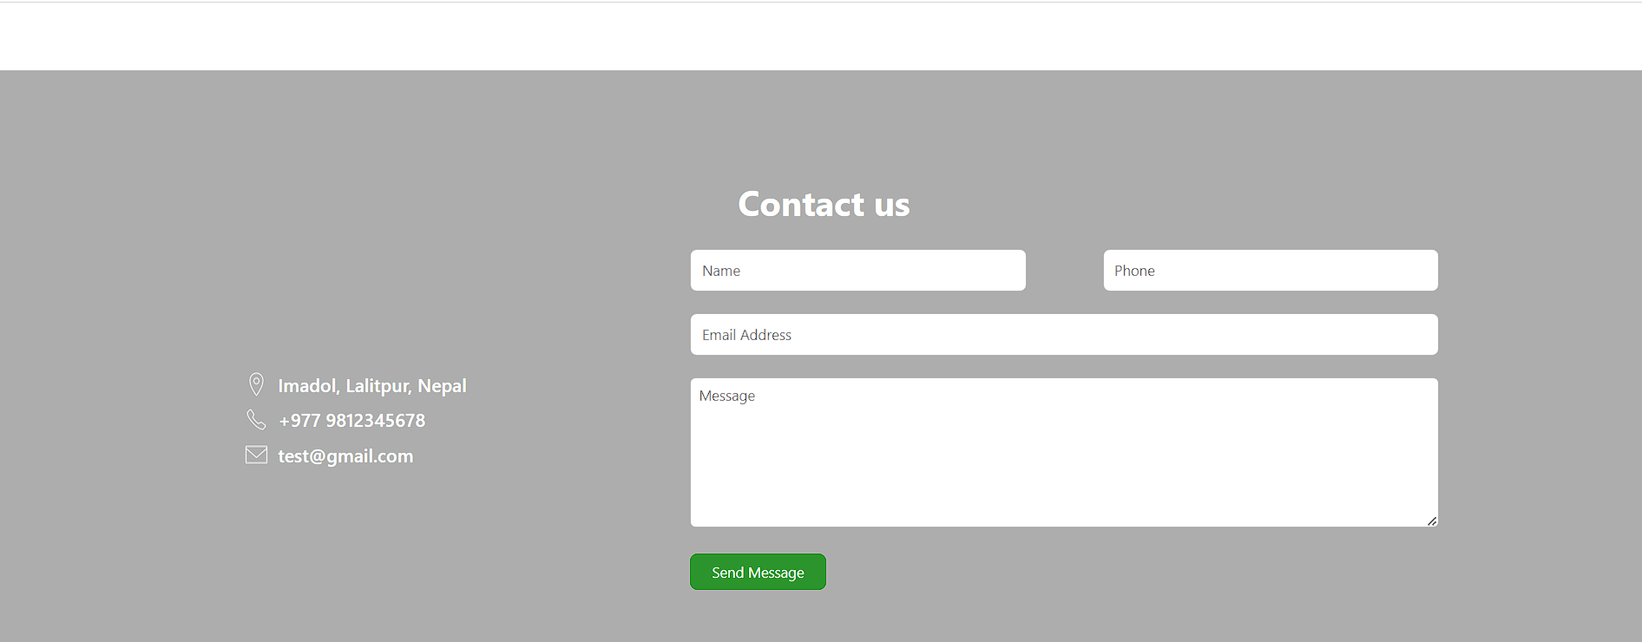

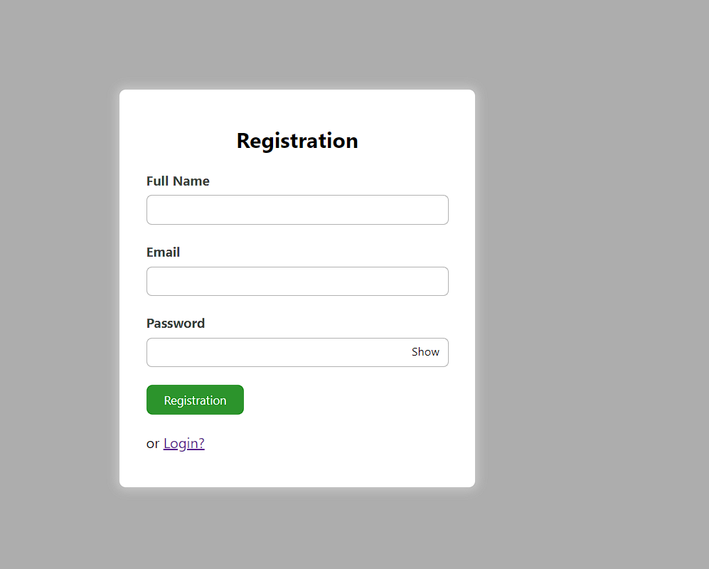

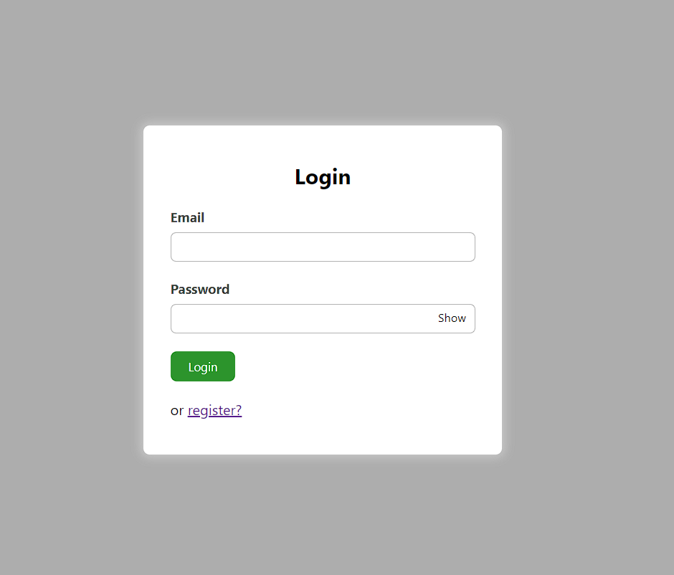

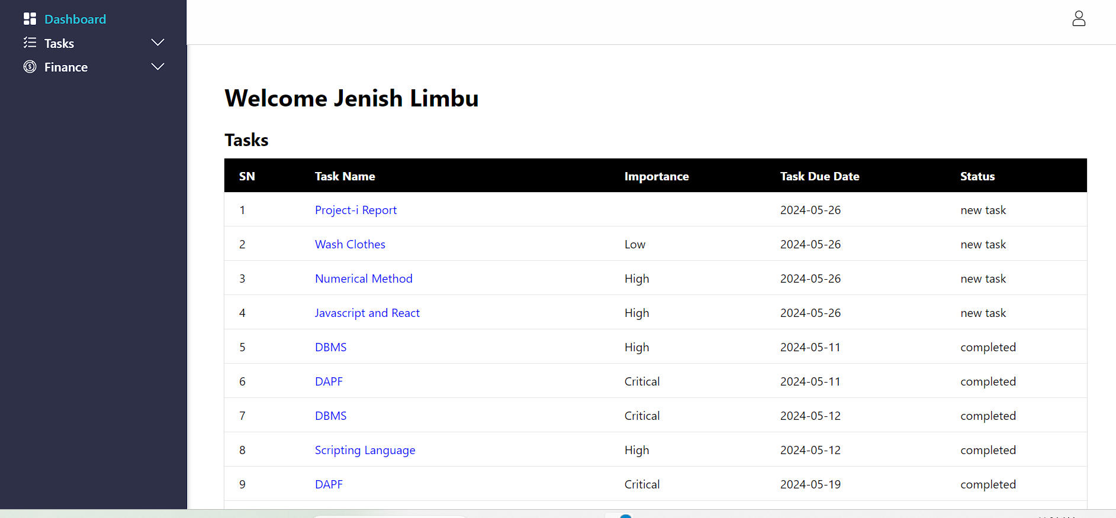 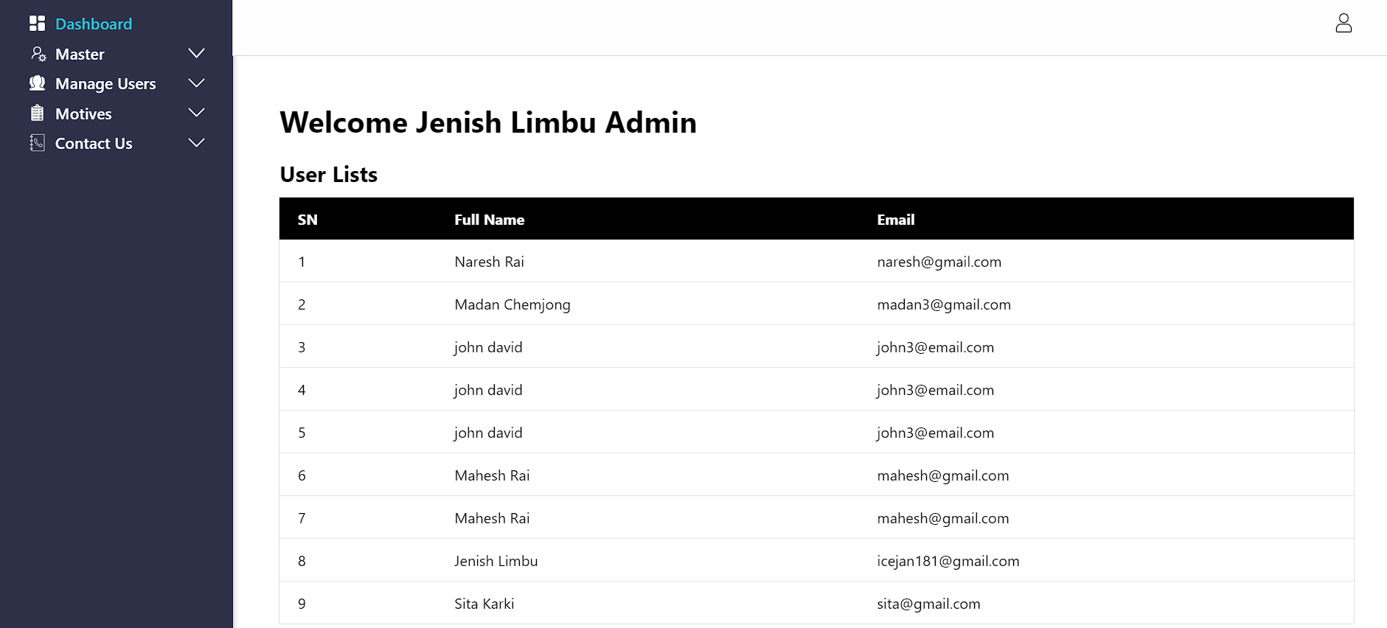

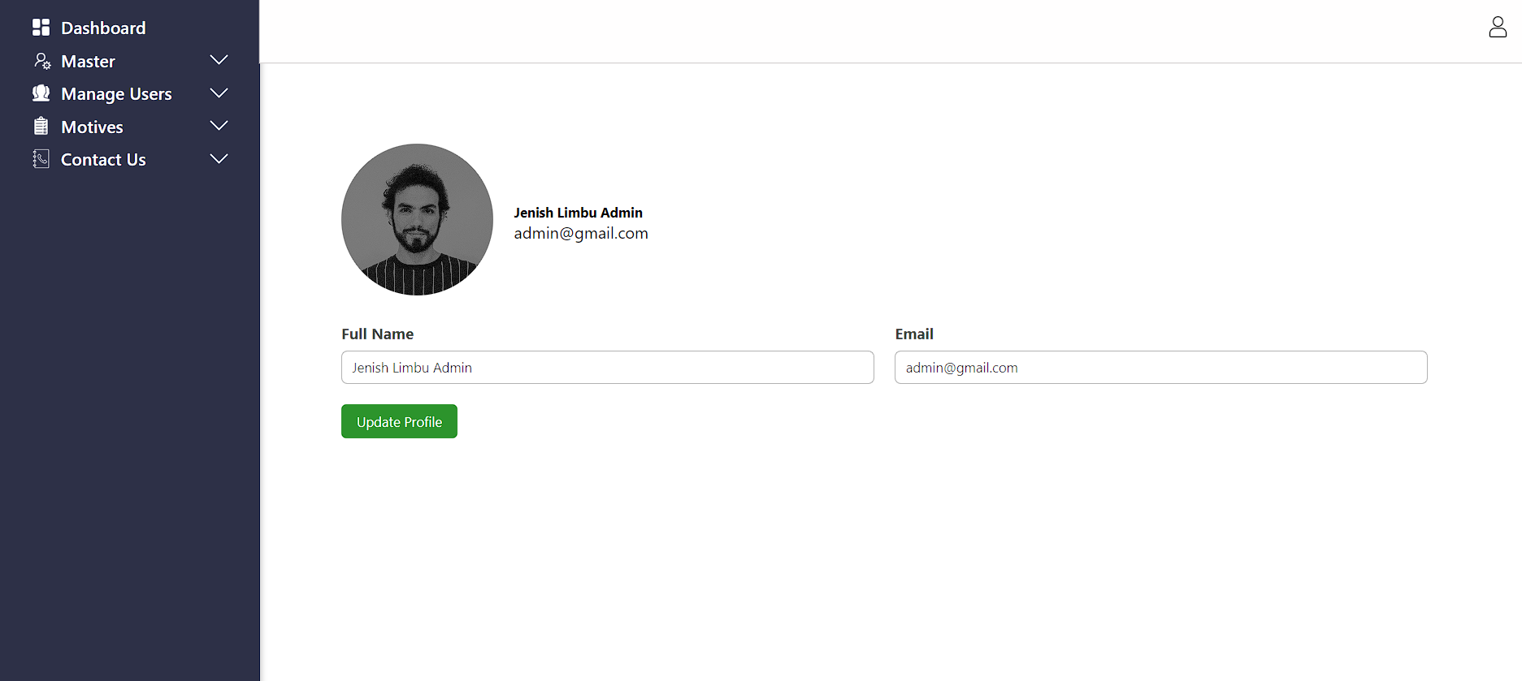

### **3.2.5. System Flowchart**

**For Admin:**

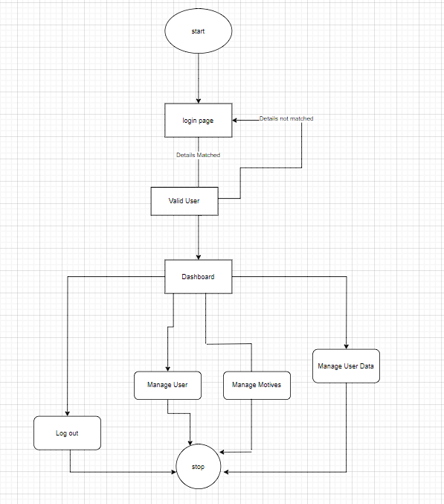

**Figure: System Flowchart for admin panel**

**For Users:**

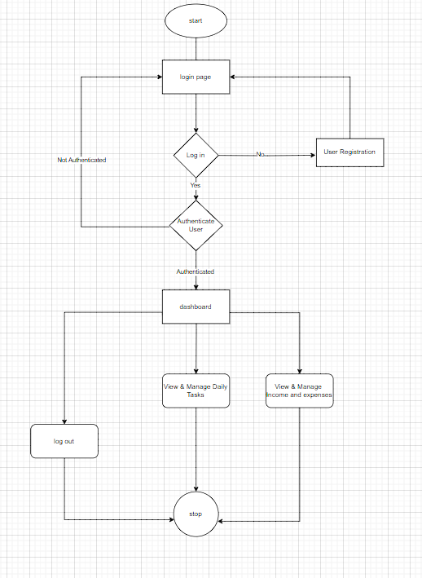

**Figure: System Flowchart for user panel**